

Value of “a” according above problem

a = RoundDown(log2(m)) + 1

Step that executes this program is

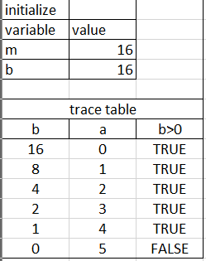

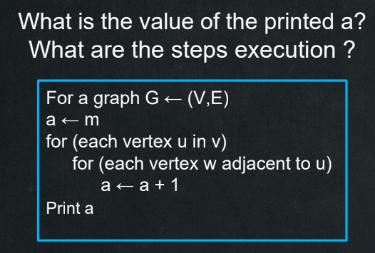

Value of “a” according above problem

a = m + (E x 2)

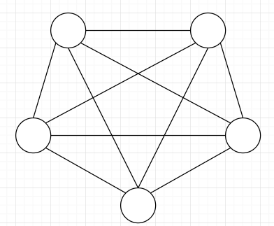Step of execution   
given a graph  
G <- (5,10)

First iteration

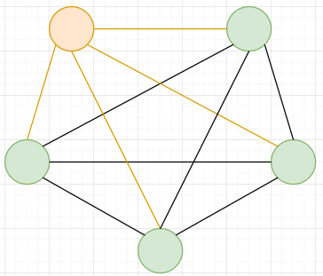according the pseudocode

it chooses 1 node and reach their

adjust node   
each adjust node reached increase

“a” by 1 in my example it increases

“a” by 4 for each node the iteration chooses.

Do it util all node is choosing

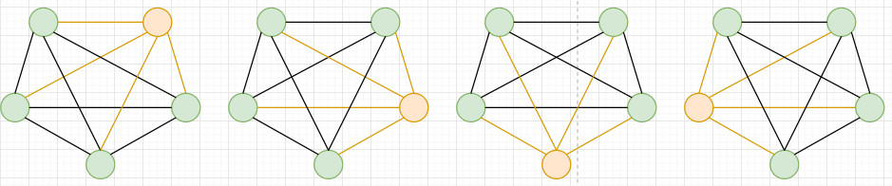

Now a will be

a + m + 4 + 4 + 4 + 4 + 4 or a + m + 20   
or a + m + (10 x 2)